Check-In



Prepared for
[Customer.FirstName] [Customer.LastName]
[Customer.Company]

2025-03-23

 | Agenda
- Your PandaDoc Team
- Account Overview
- Objectives
- Success Keystones
- Success KPI Metrics
- How to Improve Success KPI Metrics
- Your Experience
- Editor 2.0
- Feedback
- Upcoming Renewal
- Resources
{{PANDADOC_TEAM}}
 | Account Overview
Company details | Location:  Company Size:  CRM:  Account Owner: | [BillingCountry]  [NumberOfEmployees] employees  [CRM__c]  [PD_Owner_First_Name__c] [PD_Owner_Last_Name__c] [PD_Owner_Email__c]
Subscription info | Start date:  Plan level:  Add-ons:  Editor: | [Customer_Acquisition_Date__c]  [recurly_v2__Recurly_Plan_Name__c]  [Add.ons]  [Editor_Version__c]
Usage details | Seats:  Teams on PandaDoc:  ​ | ​[Paid_Seats__c]  [Teams]  ​  ​

 | Objectives
past objectives  [Customer_Objectives__c] | past objectives achieved?
new objectives | action items
​
​
​

growth plan | notes
short term:
long term:

Success Keystones

 | 1. Content created and maintained  ​  Achieved?  ​  Owner:
 | 2. All users attended team training  ​  Achieved?  ​  Owner:
 | 3. Enforcement of directives/change management  ​  Achieved?  ​  Owner:
 | 4. Regular meetings with CSM  ​  Achieved?  ​  Owner:

Workflow
Momentum happens when your workflow works for you.

Insight
Stay ahead by always knowing where you stand.

Speed
Faster Docs. Faster Deals.

Experience
Don’t just engage, make it engaging.

{{SUCCESS_KPI_TRENDS}}
 | How can I improve my Success KPI metrics?
Workflow | Experience
  template rate | template creation, content library, content locking, custom user roles, end user training
  upload rate | template creation, custom user roles, content locking, end user training
  approval rate | content locking, custom user roles, approval groups and order
  time to approve | content locking, mobile app for on the go approval, approval groups and order
  CRM rate | integration setup, template creation, variables, end user training
  close rate | increase personalization with variables, logo images and case studies, more dynamic document with images and videos, document analytics, link sharing, pre-filling fields, auto-reminders, manual reminders, public chat, doc forwarding + signature forwarding, proposal review/on-call close
  rejection rate | whitelabeling, branding, user profile image, send on behalf
  average deal value | optional items, multiple choice sections, discount presentation
Speed | Insight
  time created -> sent | template creation, content library, variables, integration setup, saved messages, end user training, version history, bulk send, collaboration via inline commenting
  time sent -> completed | whitelabeling, branding, document analytics, link sharing, pre-filling fields, auto-reminders, manual reminders, public chat, doc forwarding + signature forwarding
  time viewed -> completed | document analytics, link sharing, pre-filling fields, auto-reminders, manual reminders, public chat, doc forwarding + signature forwarding
  expired documents | custom expirations, auto-reminders, manual reminders, public chat, doc forwarding + signature forwarding, pre-filling fields, link sharing, branding, whitelabeling

How Would You Rate Your PandaDoc Experience?

How happy are you with your PandaDoc experience?
(Scale of 1-10 with 10 being the best)

Why Did You Select This Score?​  ​  How Can I Help You Achieve a 10 & Be Successful?  ​ | 

Editor 2.0 Packs a Punch  ​  Upgrade to to the most powerful PandaDoc Experience yet, and gain access to:  - A more modern and enjoyable editor  - Automation to make collaboration easy  - New features like Forms, Redlining and more!  Don't fall behind and join the thousands of companies already using Editor 2.0.  End of Classic Editor Bug Fix: June 30, 2021 | 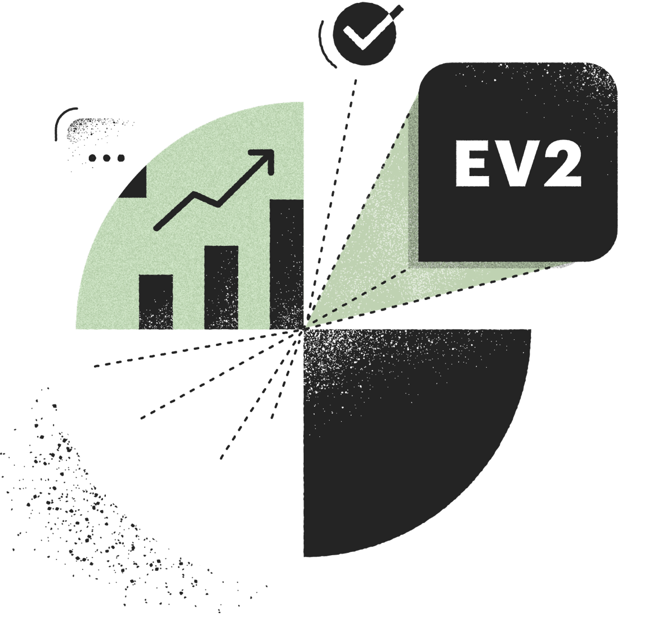
Want to chat through your upgrade plan and timeline?  Books a call with us: | Next Steps:
Ready to upgrade?
Download our Upgrade Guide and End-User Guide to ensure a smooth transition.
Please be sure to read our FAQ if you have any concerns about how this might affect your workflow.

When you're ready, fill out this form and our support team will upgrade your account to editor 2.0 and migrate your templates and content library over to the new editor.

Feedback

Please take this 5 question survey to tell us your feedback about the Success KPIs and help us improve what we are measuring and sharing.



Upcoming Renewal:

[PandaDoc_Contract_End_Date__c]

We're looking forward to another great year helping [Name] grow!  ​  Plan: [recurly_v2__Recurly_Plan_Name__c]  Subscription Details: [Add-ons or API calls]  Seats: [Paid_Seats__c]​  Next Steps: [Next Steps]  Last Day to Make Changes: [90 days before renewal date] | 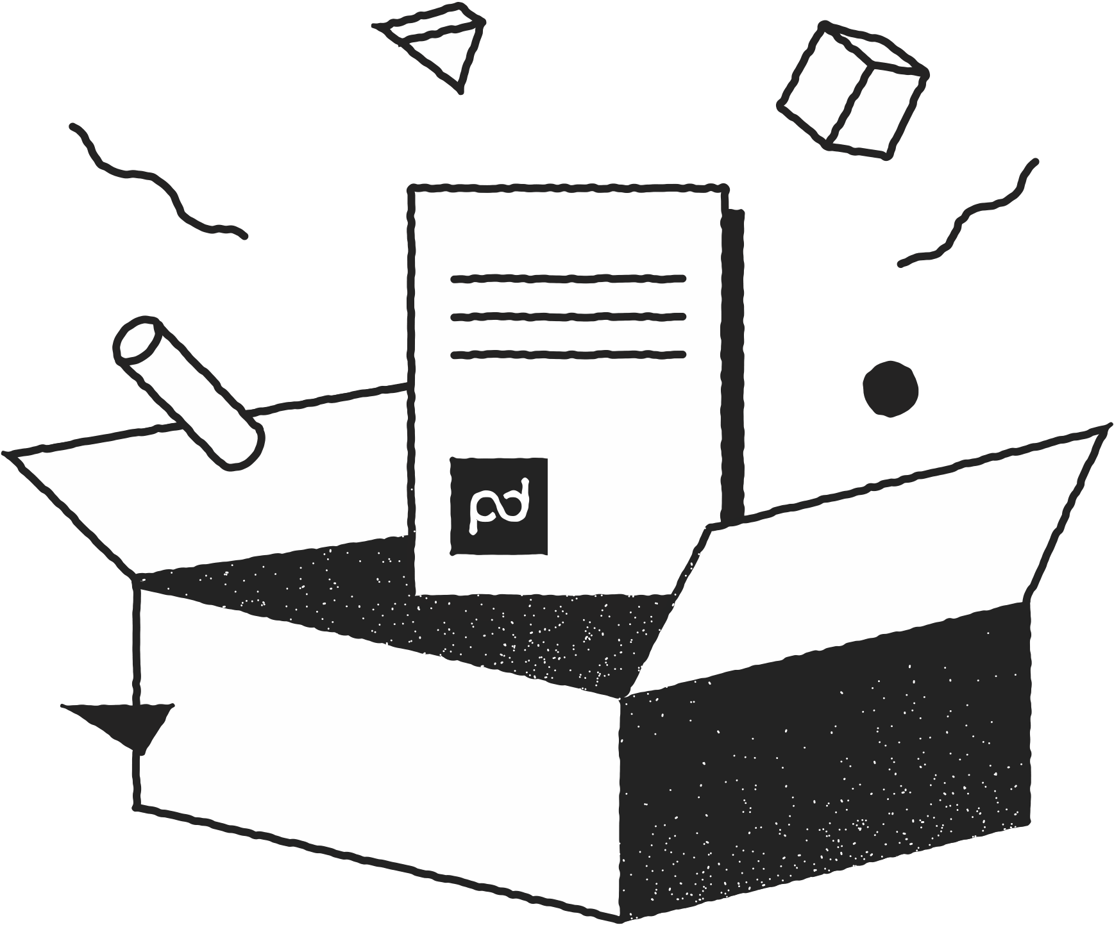

 | Resources
Community Forums  Collaborate with businesses like yours in a forum where you can share best practices and find creative ways to use PandaDoc  ​Webinars  Several days a week we offer live webinars that cover basic product admin training and migrating to PandaDoc’s new editor. More weekly series are coming soon, so check back often.  Unleashed  Customer-only webinars, best practices, articles, videos, and guides that will fuel your success.  Training  Expand your product knowledge with in-depth trainings to maximize your product usage.  ​  Onboarding Services  Our team offers a comprehensive suite of onboarding services to get you and your team up and running in no time. | Help Center  Tap into a vast knowledge base built by a team of experts that feature how-tos, guides, and instructive videos  Product Requests  Submit a product idea directly to our team  Product Updates  Timely updates to keep you in-the-know of the latest features and functionality PandaDoc has to offer  Contact Support  Submit a ticket to the link above or email support@pandadoc.com  ​  Status Page  View the status of our platform at any given time or subscribe for updates



Thank you!

3739 Balboa St. #1083
San Francisco, CA 94121
pandadoc.com

